Lab1: Write your own shell

Displaying a prompt to indicate that it is ready to accept a next command from its user,
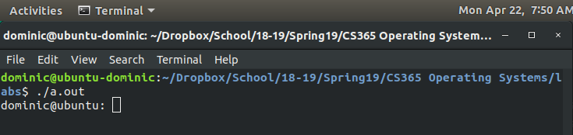
Take external commands, such as, ls, emacs and so on.
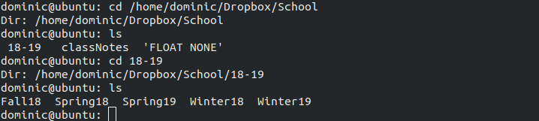
Take internal commands
exit: terminate the shell.
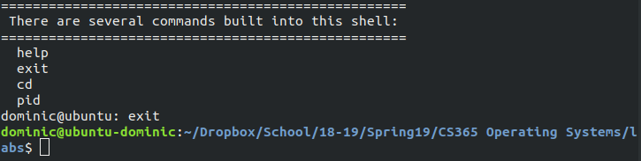

pid: print out the current pid.
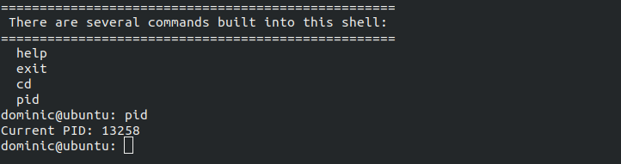
help: help information of your shell.
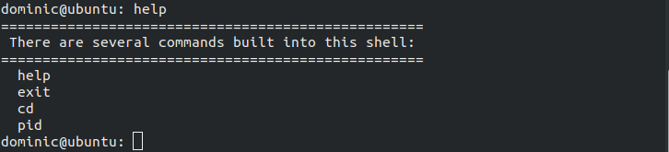
Using “&” to implement multiple commands in one line

HAHAHAHAAHAHAHAHAHAHAHHA kill me...I could not get this even remotely implemented.

